Capstone Project : Data Analysis of Cab Booking Systems
Submitted By : Anshu Yadav
Course : MySQL
Institution Name : IT VEDANT
DATE :

INTRODUCTION
The Cab Booking System is a database management project developed using MySQL.
This project helps manage cab bookings, customer details, driver information, payments, and trip records efficiently.

OBJECTIVES
- To manage customer records
- To store driver and cab details
- To handle cab bookings
- To maintain payment information
- To reduce manual work
Software requirement
- MySQL
- MySQL Workbench
- Windows Operating System

Database design
- Customers
- Drivers
- Cabs
- Bookings
- Payments

Sql queries

Create database

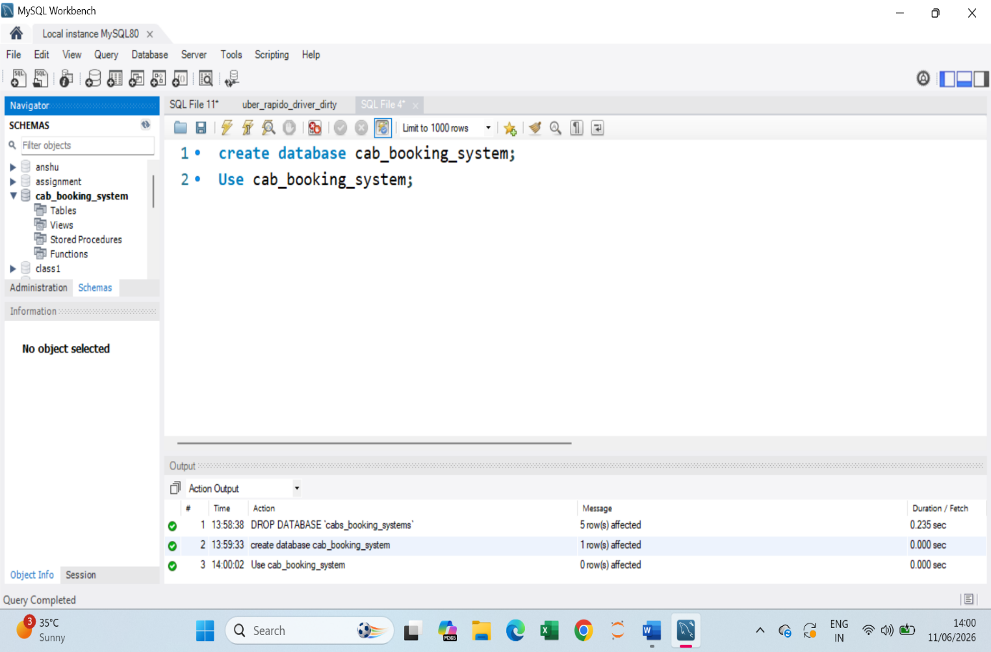

Customers Table

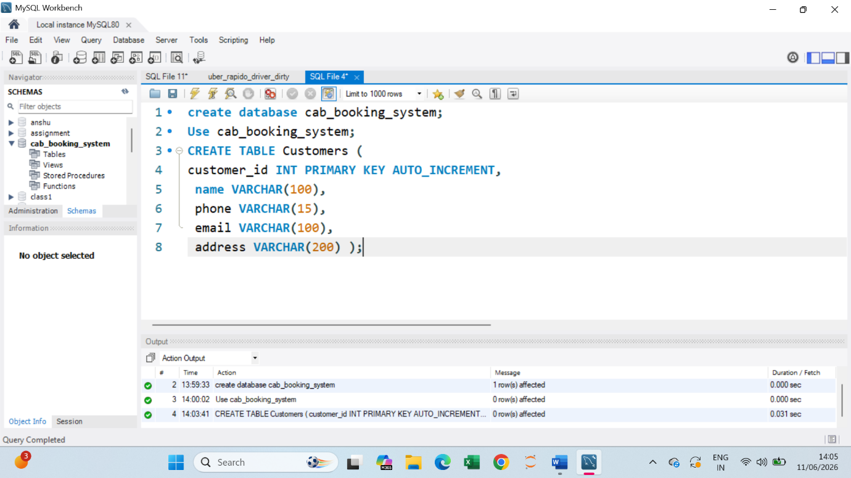

Drivers Table

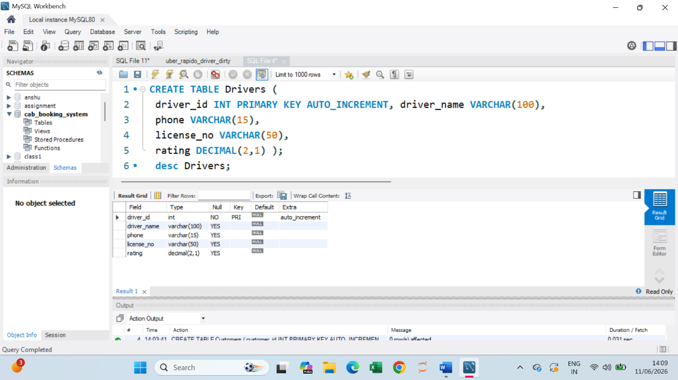
Cabs Table

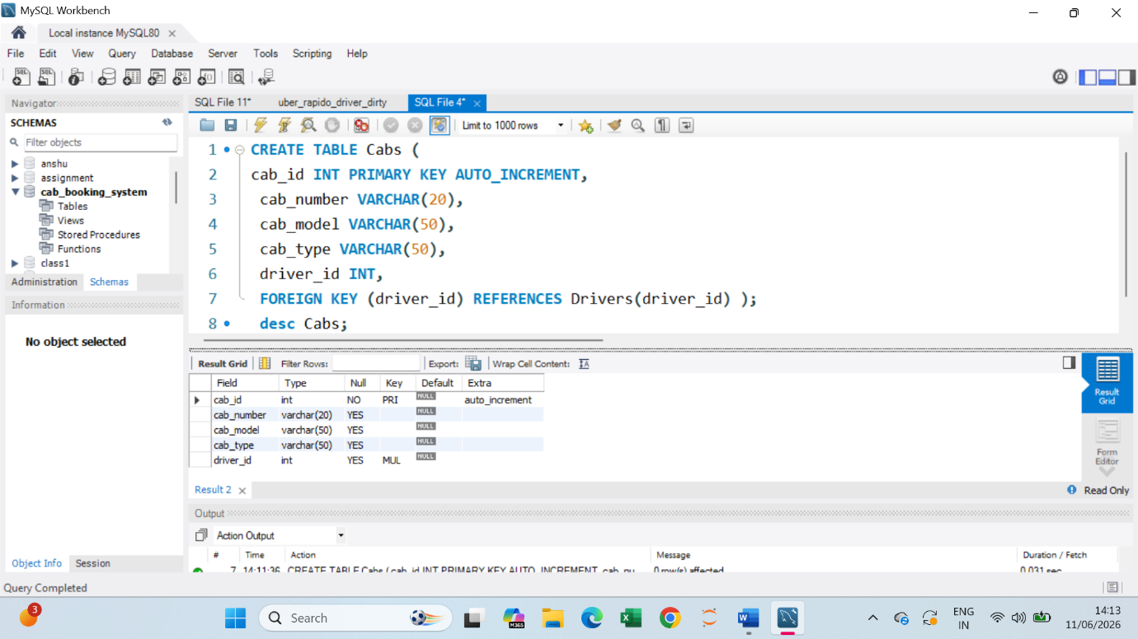

Booking Table
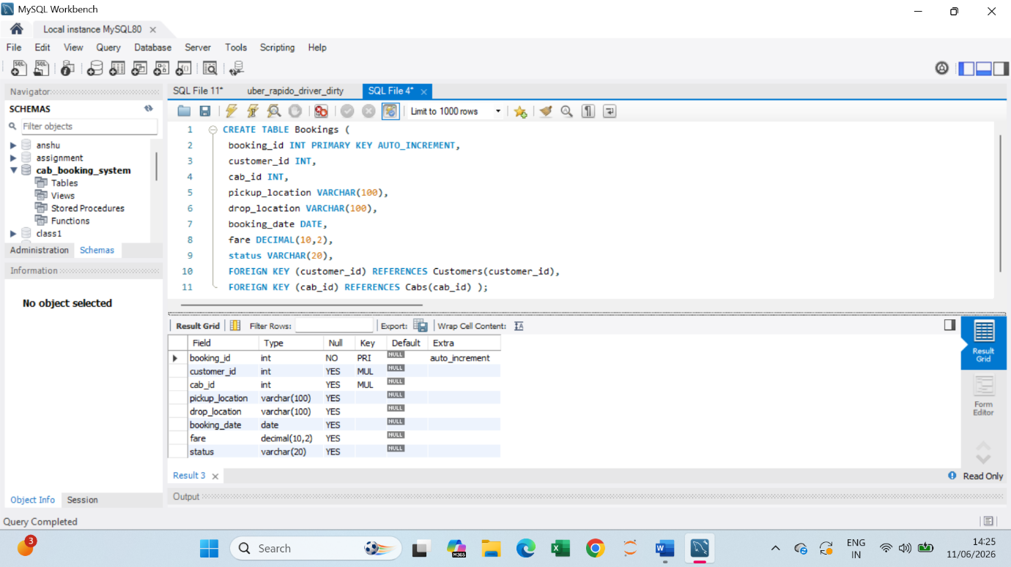
Payments Table

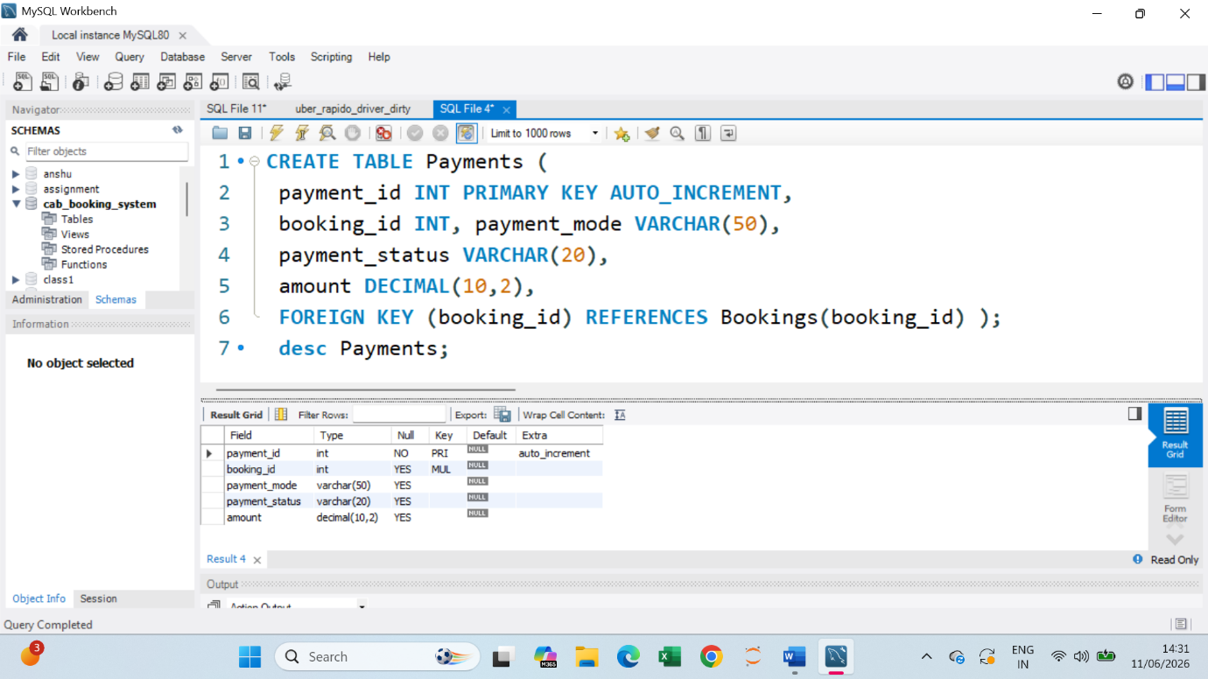

Insert queries
- Insert into Customer
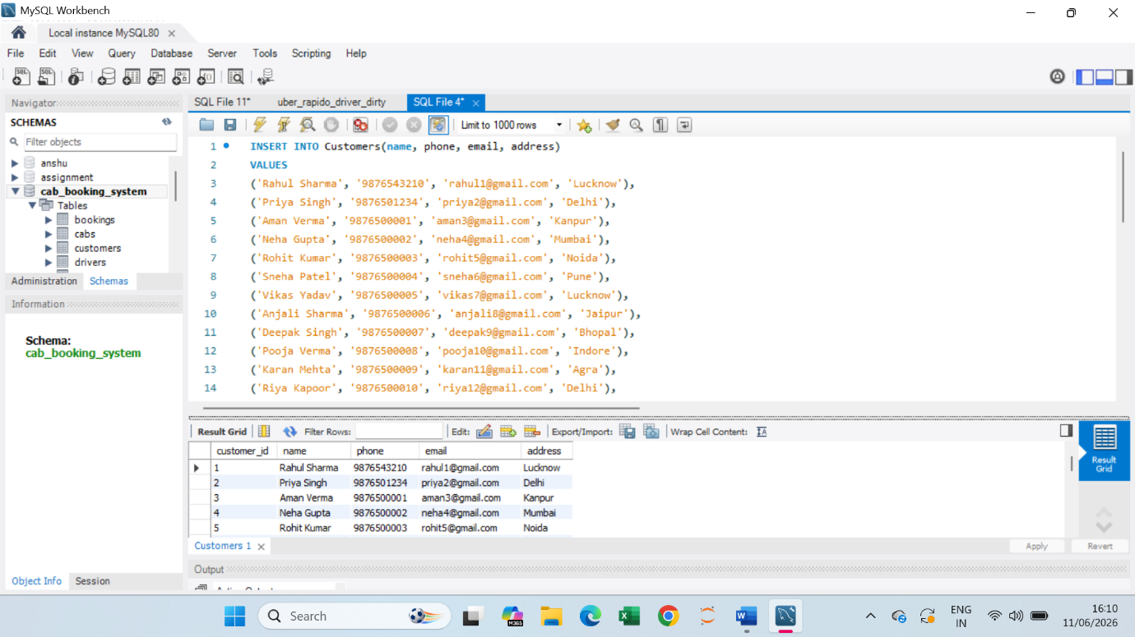
- Insert into Drivers
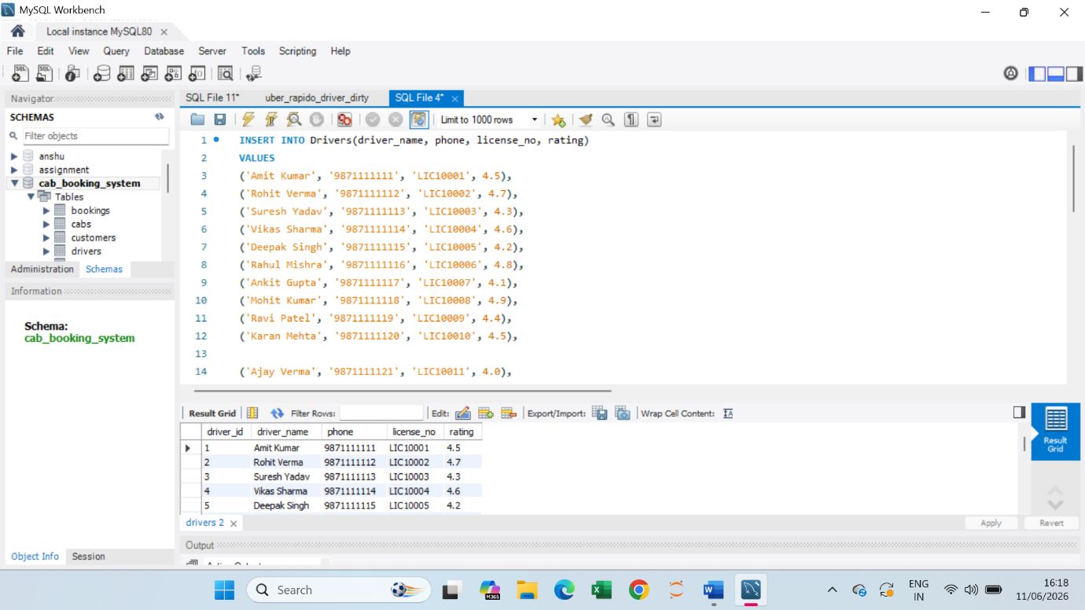
- Insert into Cabs
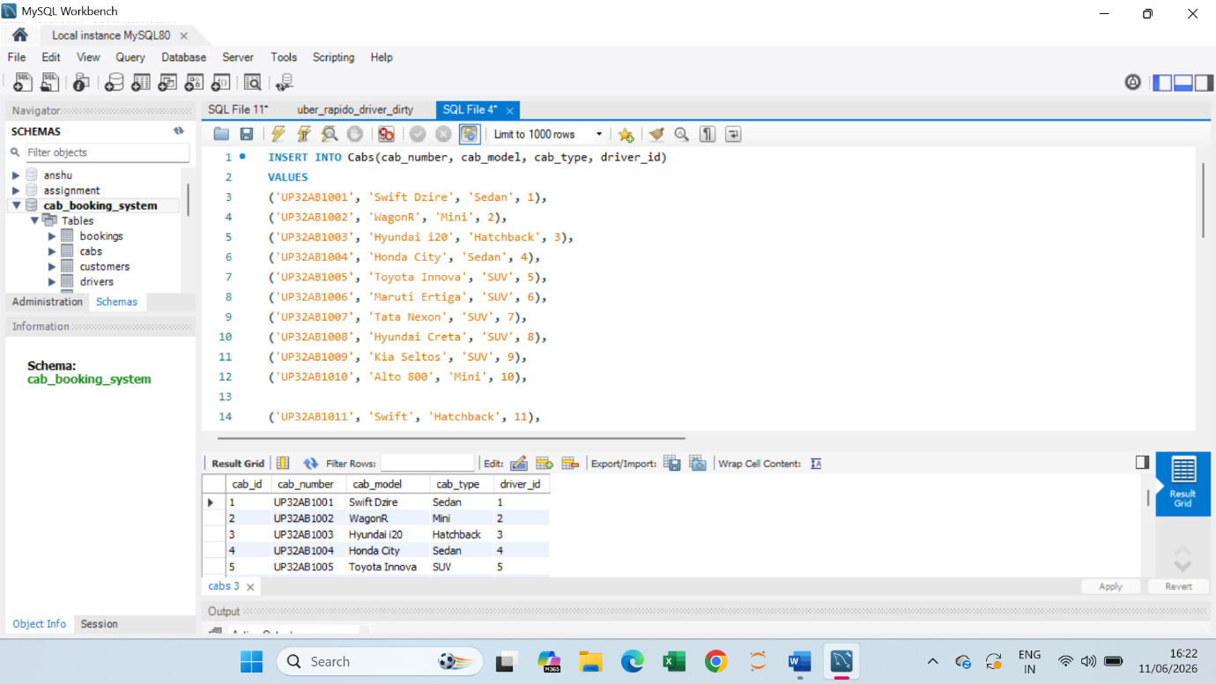
- Insert into Booking
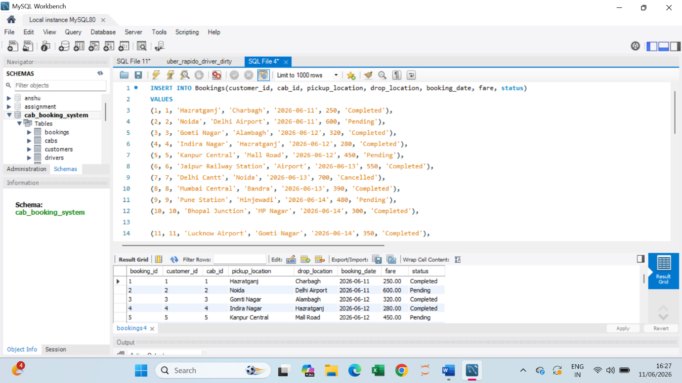

- Insert into payments
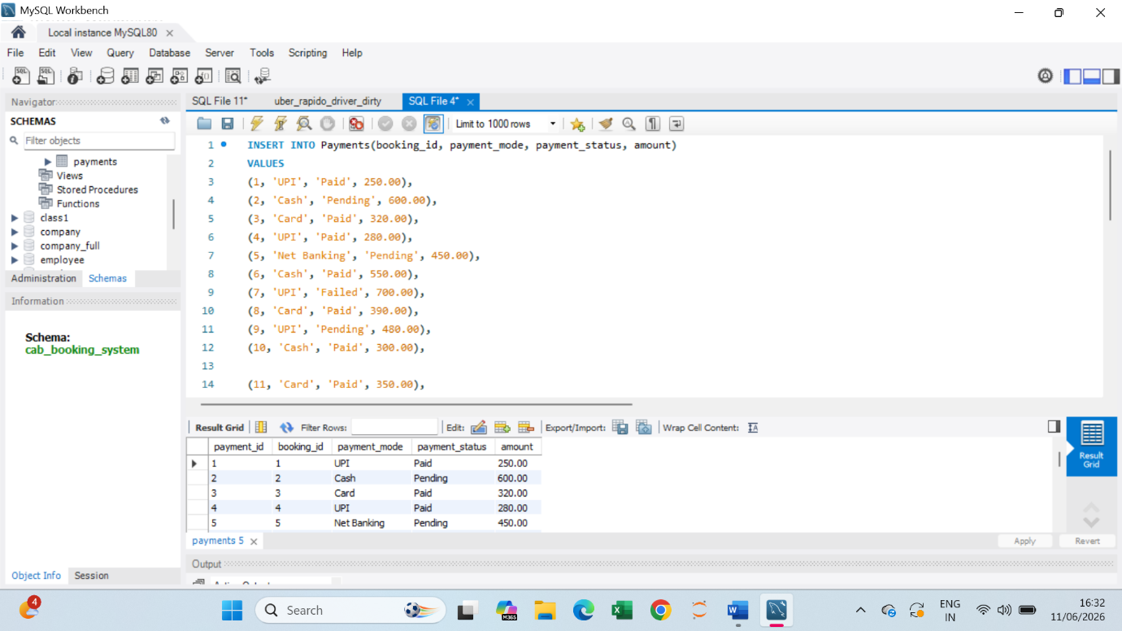

queries
- Display all customer records
Query : Select * from Customers ;
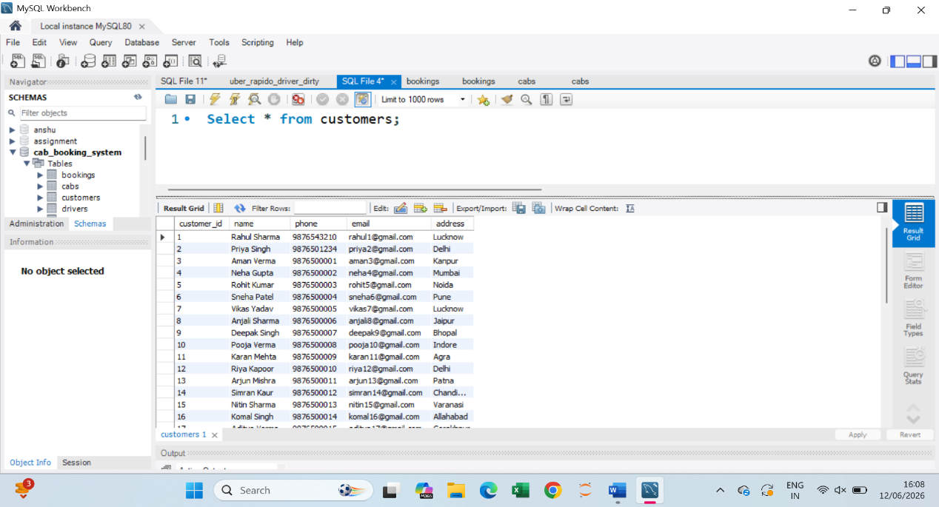
- Display customer names and phone numbers
Query : Select name, phone from Customers;
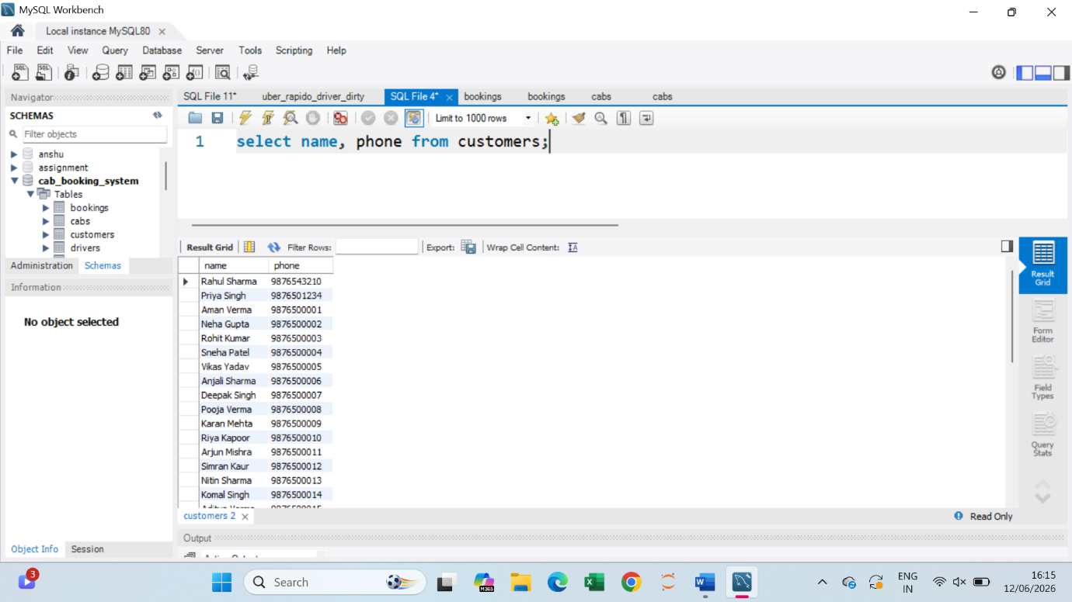
- Find customers from Lucknow
Query : Select * from Customers where address = ‘Lucknow’;
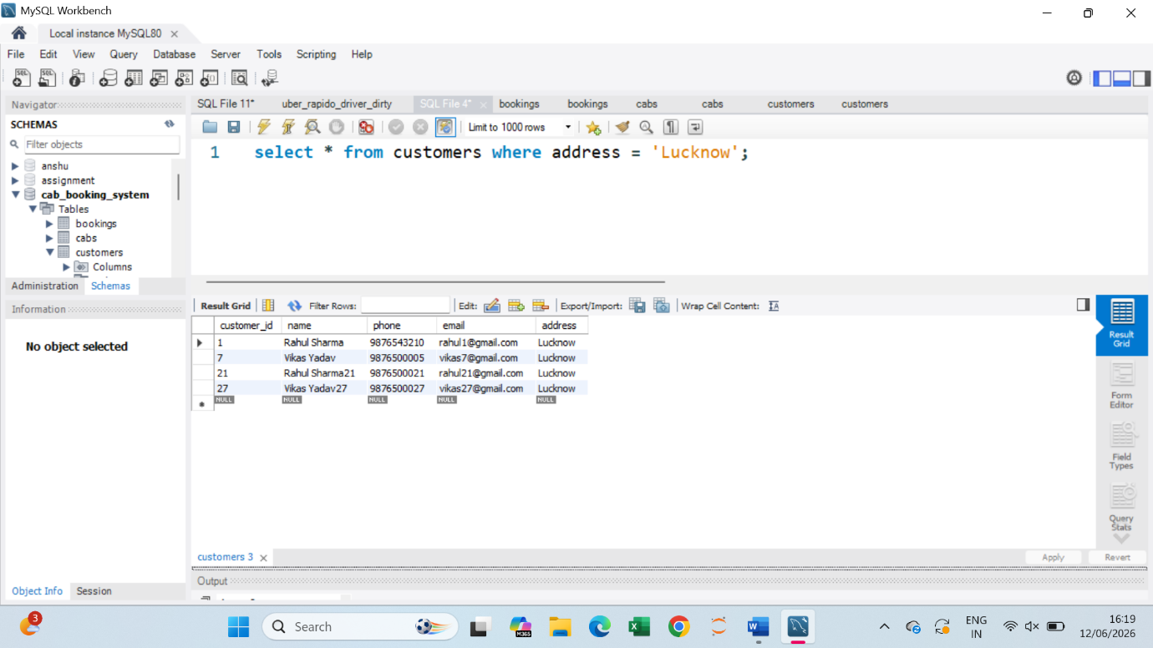
- Sort customers by name
Query : Select * from customers order by name ASC;
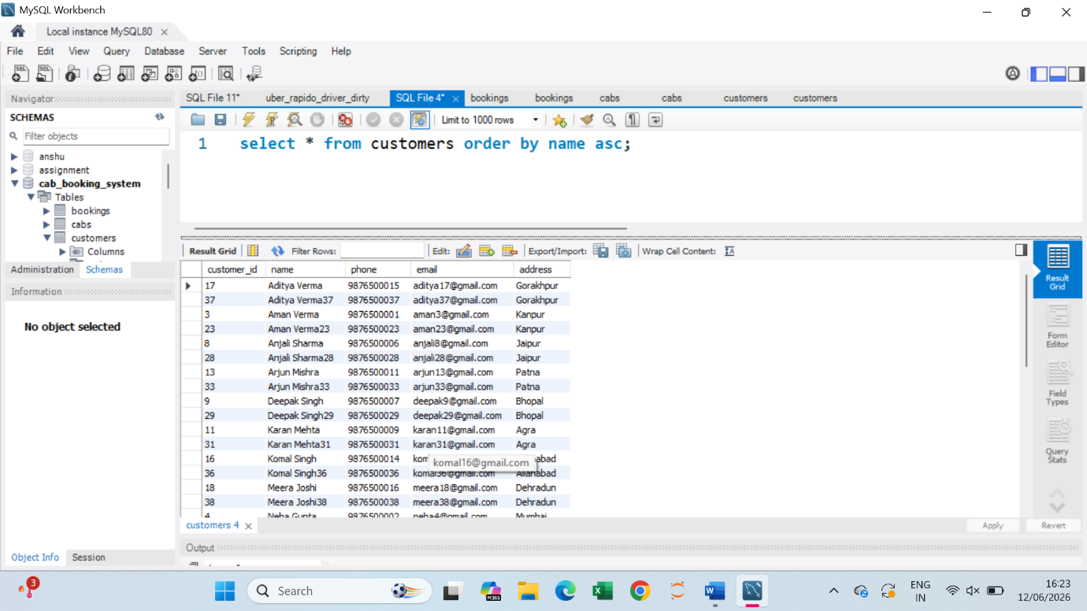

- Display first 10 customers
Query : Select * from customers limit 10 ;
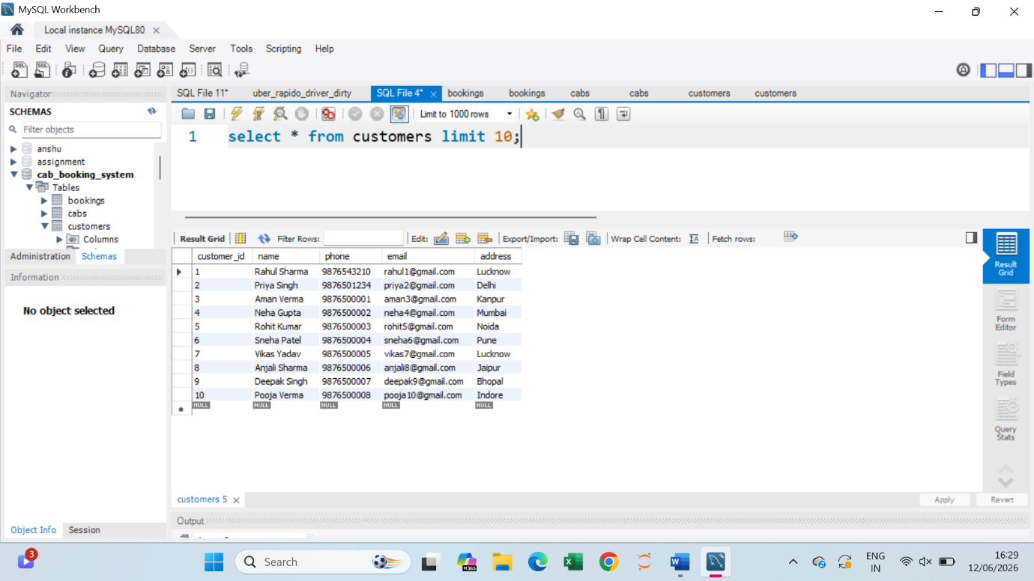

- Count total customers
Query : Select count(*) as total customers from customers;
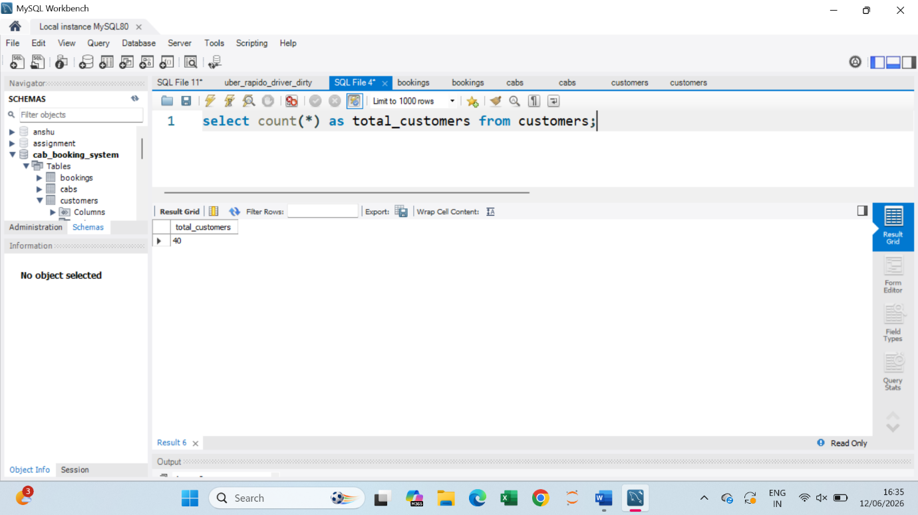

- Count customers city-wise
Query : select address, count(*) as total from customers Group by address;
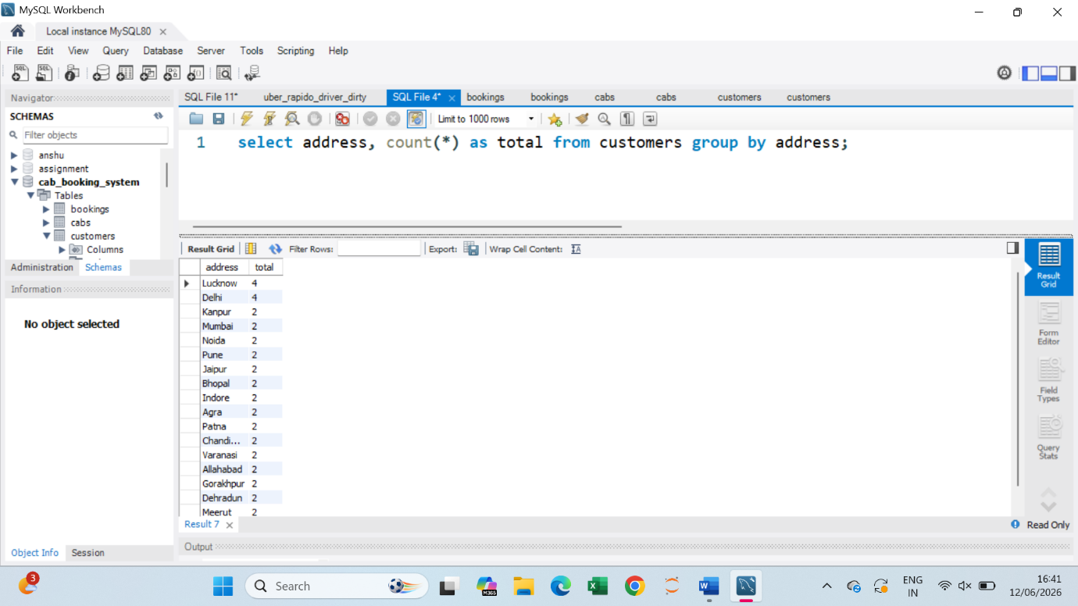

- Find customers whose name starts with ‘A’
Query : select * from customers where name Like ‘A%’;
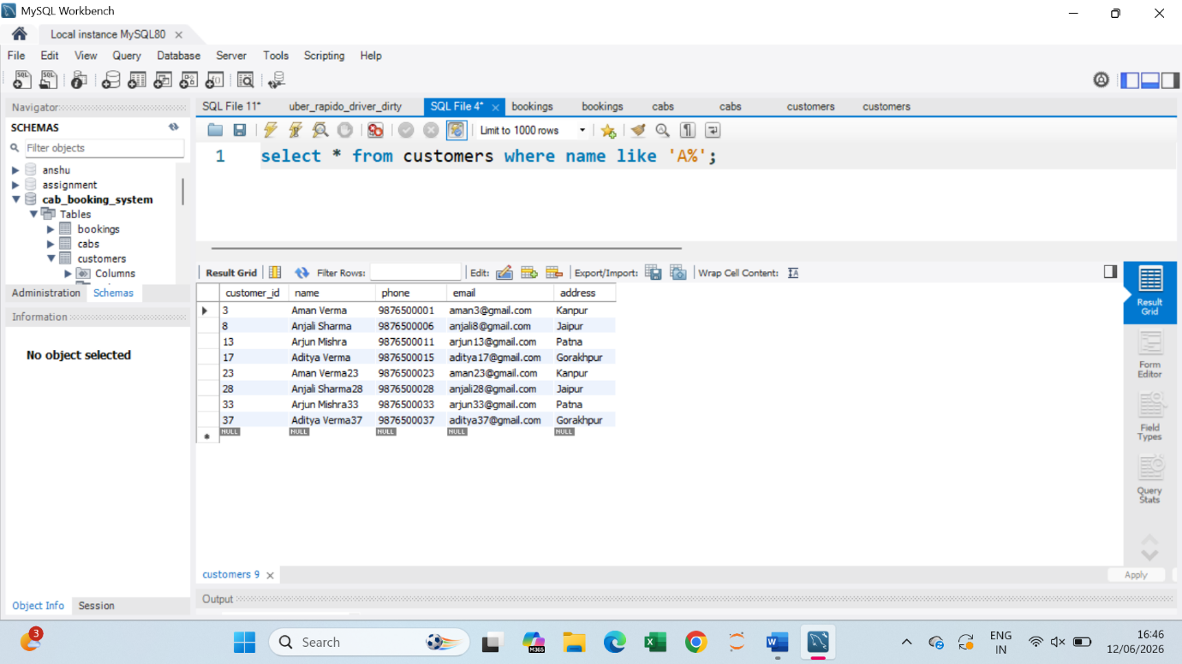

- Find unique cities
Query : select Distinct address from customers;
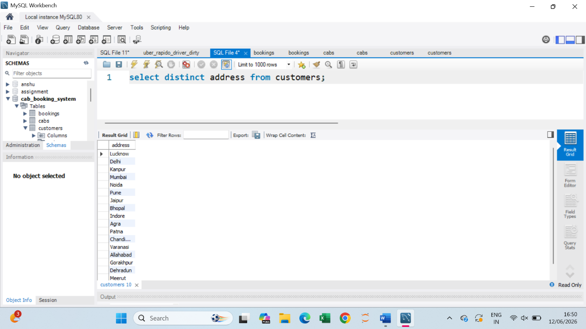

- Update customer address
Query : update customers set address = ‘ Delhi ’ where customer_id = 5;
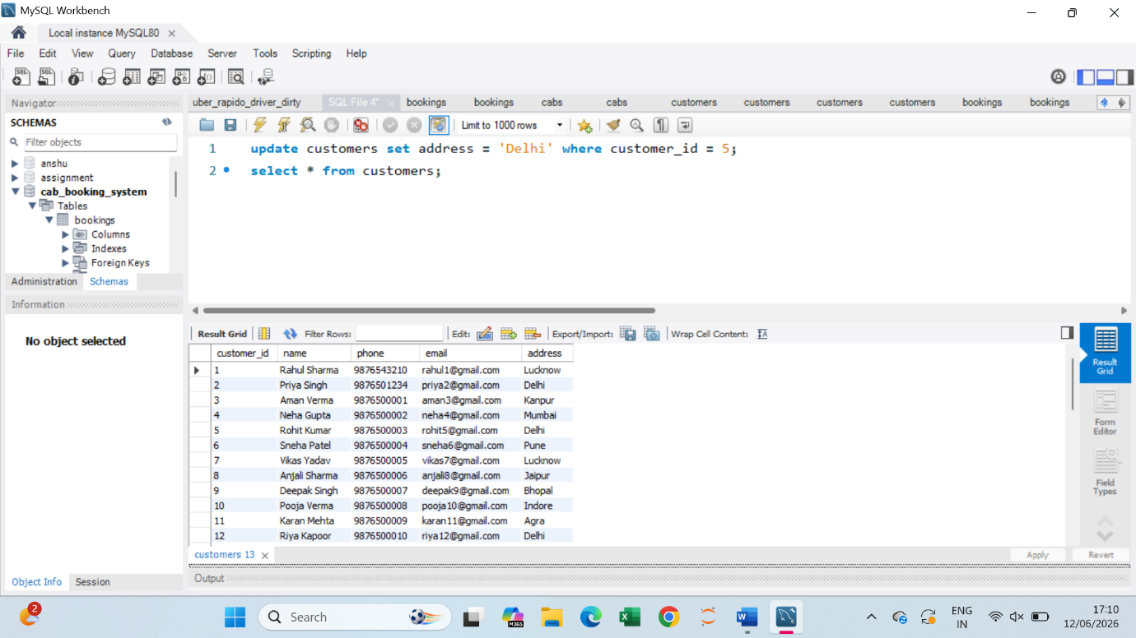

- Find customers between IDs 10 and 30
Query : select * from customers where customer_id between 10 and 30;
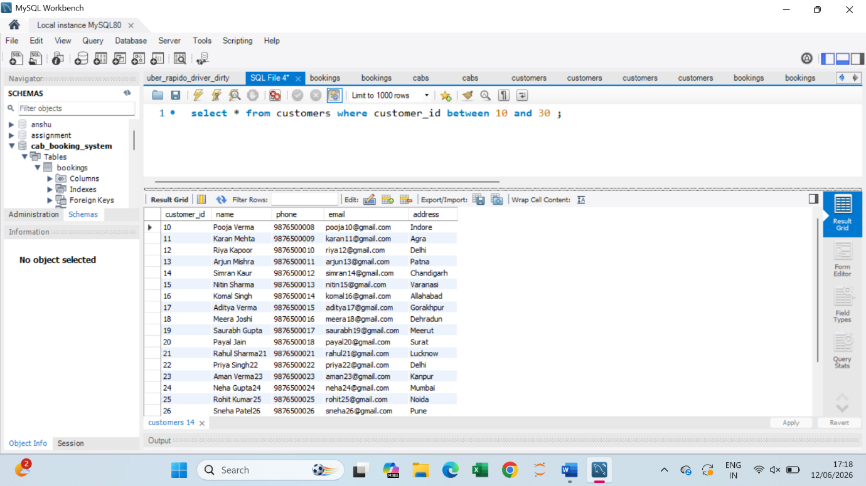

- Rank bookings for each customer based on booking date.
Query : Select customer_id, booking_id, booking_date, rank() over (partition by customer_id order by booking_date) as booking_rank from booking;
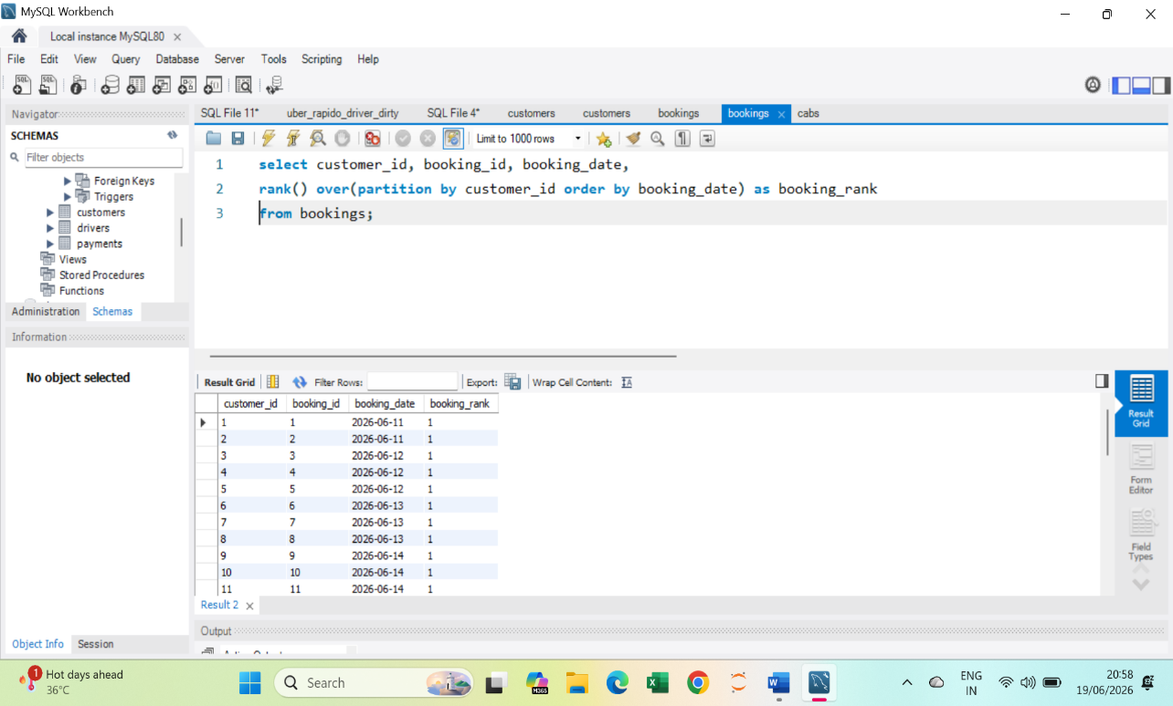

- Calculate the running total of revenue.
Query: Select payment_id, amount, sum(amount) over (order by payment_id rows between unbounded preceding and current row) as running_total from payments;
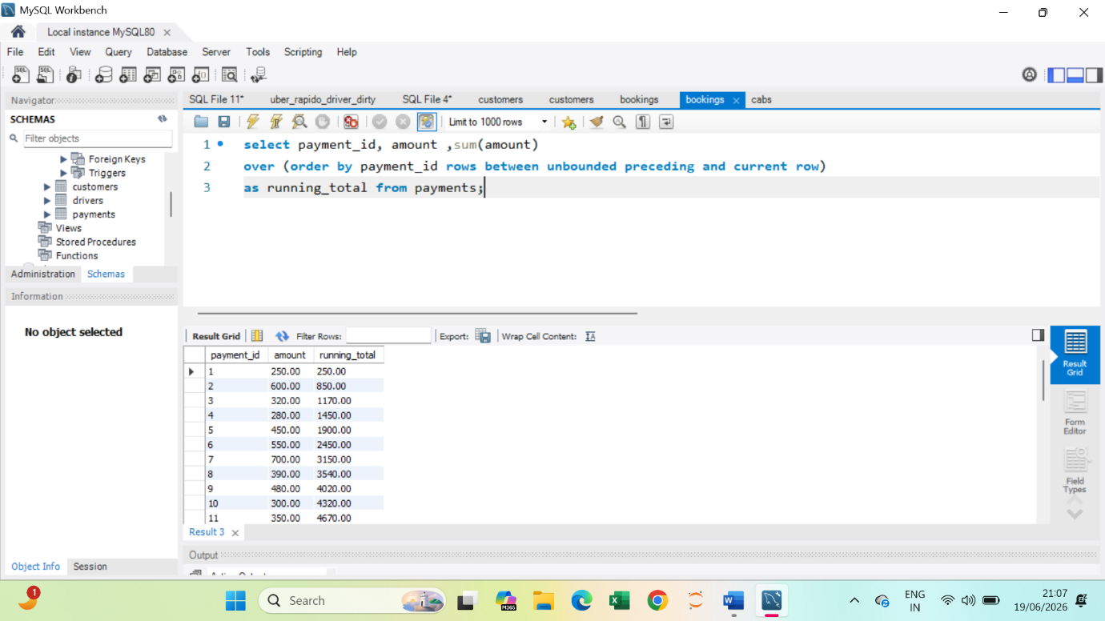

Calculate the moving average of the last 3 payments.
Query : select payment_id, amount, avg(amount)
over ( order by payment_id rows between 2 preceding and current row)
as moving_average from payments;
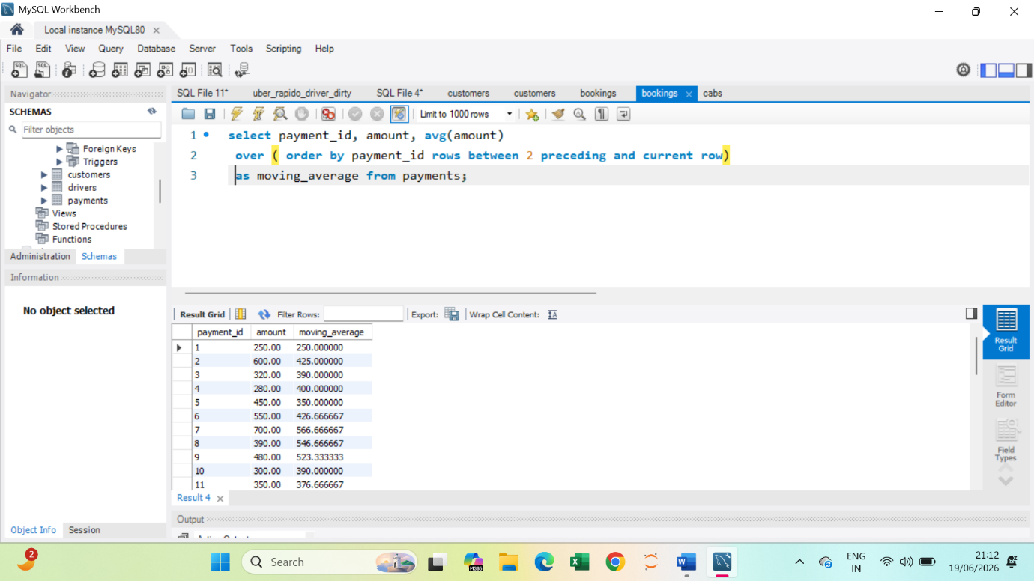
- Display driver details along with assigned bookings.
Query : select d.driver_name, b.booking_id from Drivers d left join Bookings b on d.driver_id = b.booking_id;
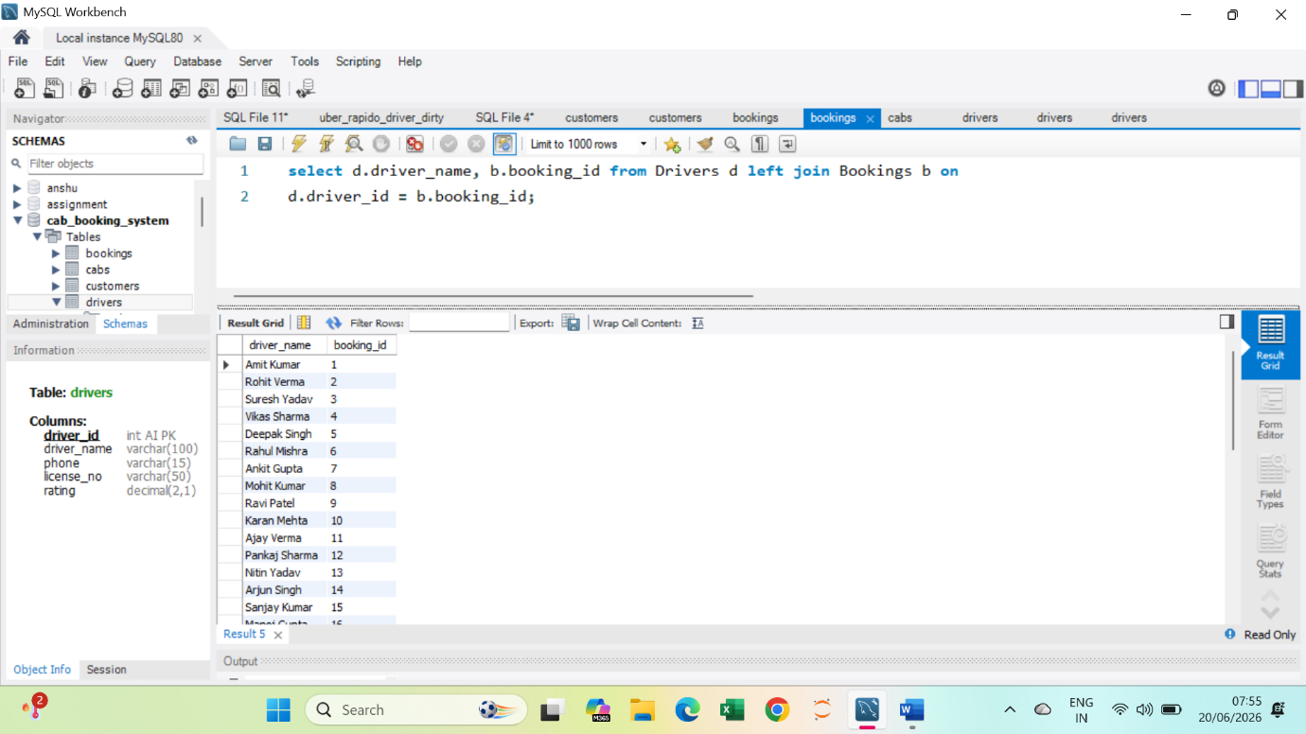
- Calculate total earnings generated by each driver.
Query : SELECT d.driver_name, SUM(p.amount) AS total_earnings FROM Drivers d JOIN Bookings b ON d.driver_id = b.driver_id JOIN Payments p ON b.booking_id = p.booking_id GROUP BY d.driver_name;
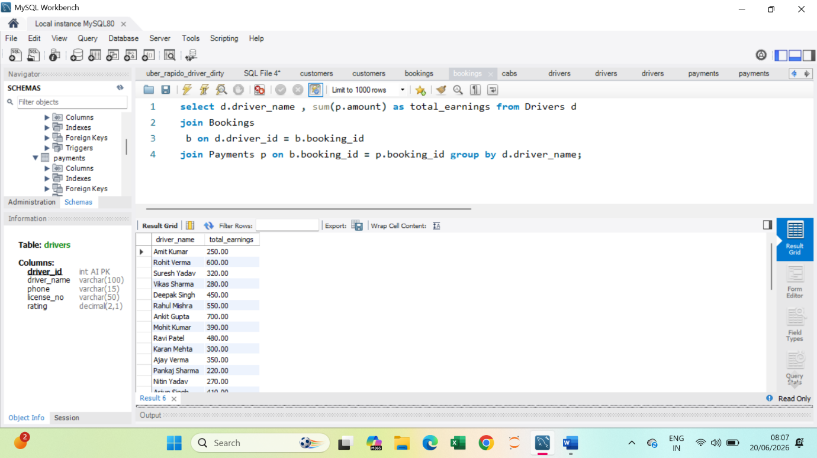
Output screenshots
- Table creation
- Inserted data
- Query results

Advantages
- Fast booking management
- Easy data storage
- Accrate records
- Secure database system

Conclusion
The cab booking system project successfully manges cab booking operations using MySQL database concepts

